This feature exports CRM customisations including schema names, labels, types and picklist keys into csv files. There are options to export

* Entity types
* Fields
* Option Sets
* Many to Many relationships

To run an export select ‘Export Customisations’ from the main menu

You may then

* Select the folder to output the csv files into
* Select which types of customisations to export by selecting their relevant checkbox
* Either Select ‘All Record Types’ or export only customisations for specific record types by adding and selecting them in the record types grid

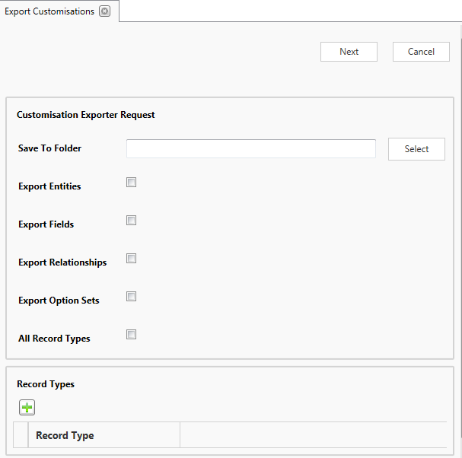

Once the above are complete click ‘Next’ for the csv files to be generated. Progress will be shown and once complete links to the files will be presented